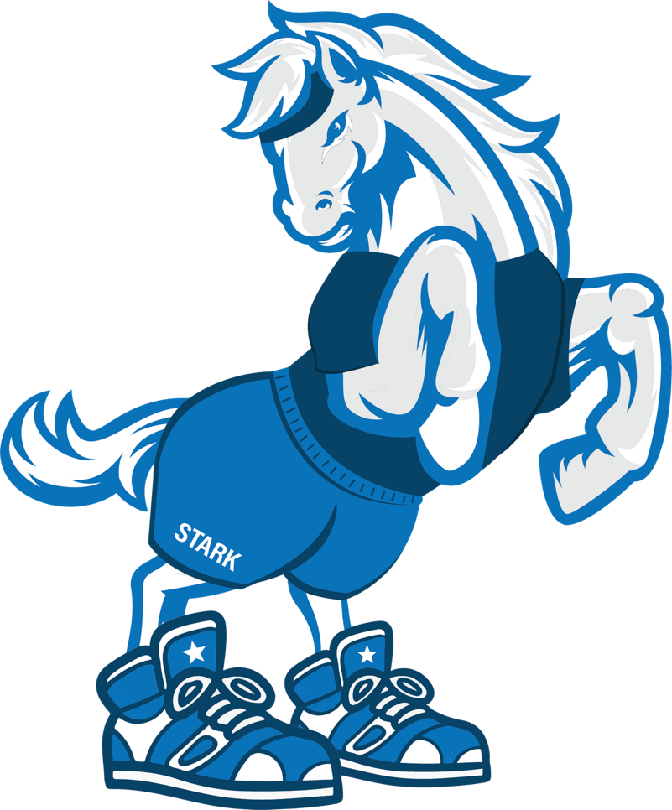
STALLION
STAMPEDE
We are thrilled to announce that Julia A. Stark Elementary School is kicking off its first-ever Stallion Stampede fundraising event! This is our biggest fundraiser of the year, and we can't wait to get started!

The Stallion Stampede is a two-week-long fundraising campaign that will begin on Monday, April 17th and end on Friday, April 28th, culminating in the Stallion Stampede Fun Run. In case of rain, the event will be postponed to Monday, May 1st. The Fun Run will be held during school hours, specifically during the students' specials.
Our goal is to raise $20,000.
We believe this is an achievable goal, based on the success of surrounding schools, and we have full confidence that the Stark community can make it happen! Additionally, we have some exciting prizes to make the event even more rewarding.

Getting Started is Easy

We will be using an online platform called Get Movin' for fundraising, but we will also accept cash or checks. If sending cash or checks, please make sure that envelopes are clearly marked with the student's name to ensure proper credit on their fundraising page.

Next Steps:
On April 17th, parents will receive links via email to set up their student's personal fundraising page. You can also scan this code on Monday.

For More Information:
Visit starkpfo.org. If you have any questions, please feel free to reach out to the PFO at info@starkpfo.org.
Stark PFO - Member PT Council

Thank you for your support!

STALLION STAMPEDE PRIZES

Weekly Drawings For Anyone Who Has Created a Fundraising Page Online | Read the morning announcements OR Pull the fire alarm at the next fire drill
 | Tablets
 | Westover Pizza gift cards
 | Cookie decorating for you and a friend with your choice of Stark staff member
 | Board game lunch bunch with Stark staff member of your choice - choose 3 friends to join you!
100% of Students in  a Class Create an Online Fundraising Page | Each student receives a prize from the Penguin Patch treasure chest
Highest Earning Class (K-2nd Grade) & Highest Earning Class (3-5th Grade) | Glow in the dark dance party in the gym
Highest Earning Class at Stark | Munchkins with Stamford's Mayor Simmons
Highest Earning Grade | Extra recess with popsicles
Highest Individual Earner (K-2nd Grade) & Highest Individual Earner (3-5th Grade) | Ride on a fire truck
Second Highest Individual Earner (K-2nd Grade ) & Second Highest Individual Earner (3-5th Grade) | Police escort to school
School Raises $10,000 by 4/23 | PJ and movie day
School Raises $20,000 | Mrs. DeRubeis dresses in a Stallion costume

